Overview of eTRIPS Mobile2
for Tablets and Phones

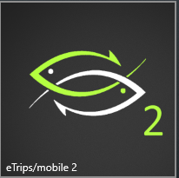

eTRIPS/mobile2 is a mobile application from the ACCSP available on Apple iOS, Android tablets and Windows 10 computers. Captains can use it for the submission of vessel trip reports (VTR). The eTRIPS mobile2 app will put Commercial and For-Hire fisherman in compliance with mandatory reporting.

Step 1: Login using your SAFIS Username and Password

Note: If you do not know or have forgotten your username and password, please email us at:

support@harborlightsoftware.com
or call the
Helpdesk at
800-984-0810
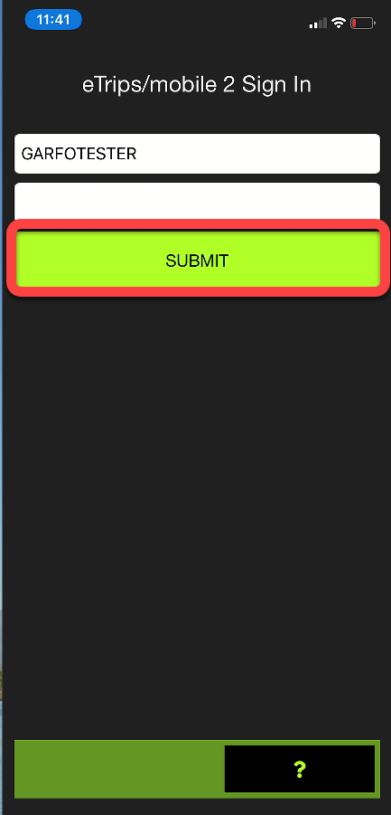

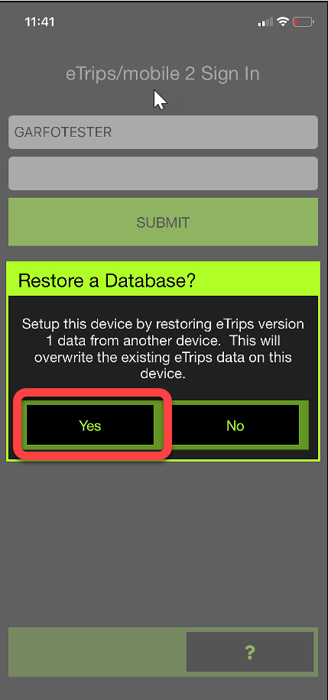
Step 2: If you are a new to the app it will ask you to back up the app from a potential past data base. Select “Yes”.

If you are new to trip reporting all together, select “No”.

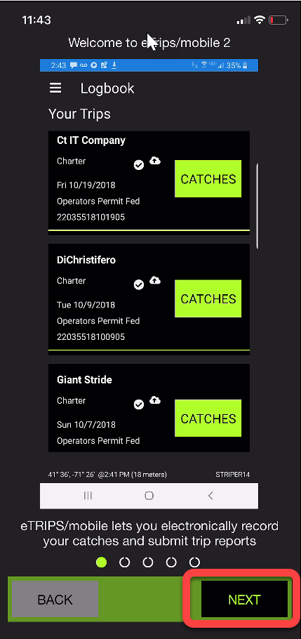

Step 3: If you are new to the app, a small directional pop up will explain some basic app features.

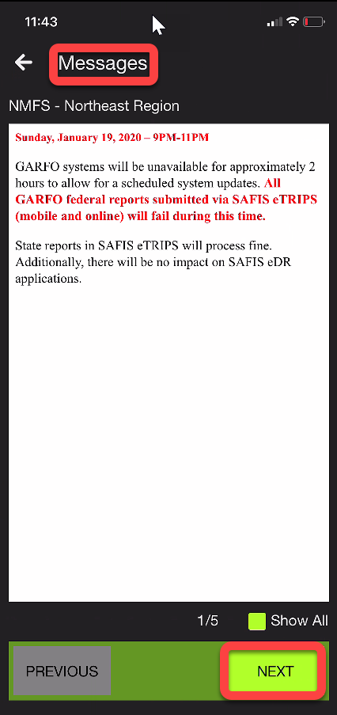

Step 4: New messages will appear, if available, when the app is opened. These are viewed once then tucked away in the “Message” section of the app.

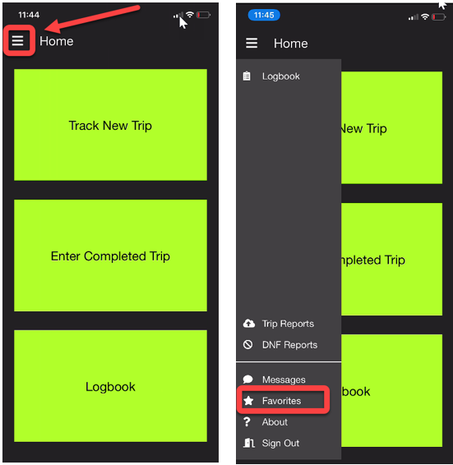

Step 5: This is the home screen you will see once you are logged in.

Additional features can be accessed through the Menu in the upper left corner.

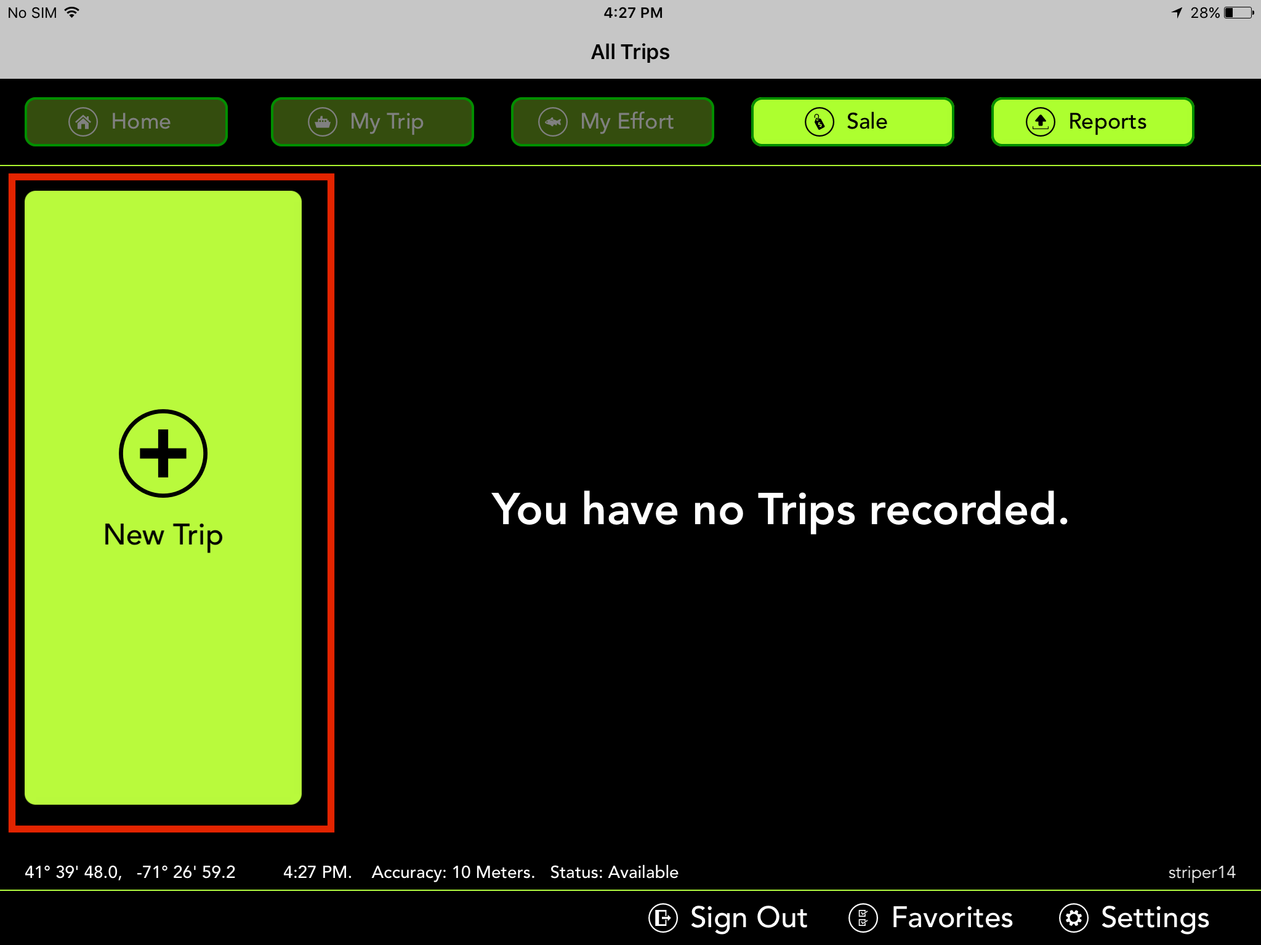

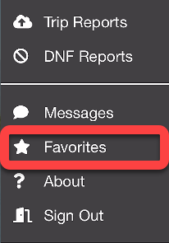
Step 6: Taking the time to set Favorites will allow you to enter and send trip reports quickly.

You must set Favorites for each permit you will use

In the top area of the screen, you will see a button that says Permit. Click on this and make sure that all your permits are visible within the app.

Note: If you believe that you are missing a permit please contact our support team at 800-984-0810
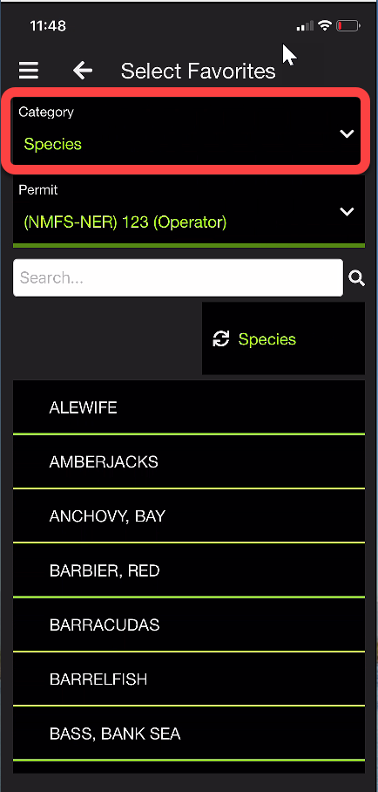

After you have selected your permit you are now ready to begin setting up your Favorites.

First select Species.

Scroll through the list and select the species you commonly catch when fishing under THAT SELECTED PERMIT. You can use the Search Bar to find specific species. Click on each species that you wish to add to your favorites list. A “star” will appear to show they are selected (clicking again will unselect)
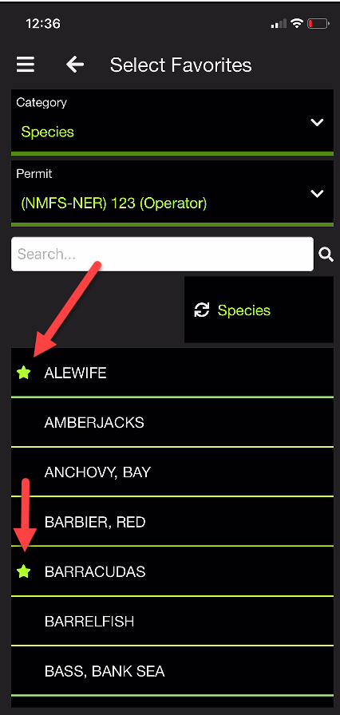

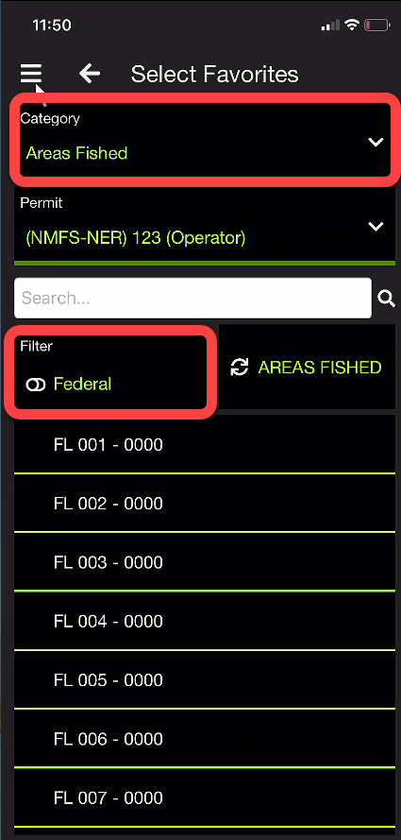
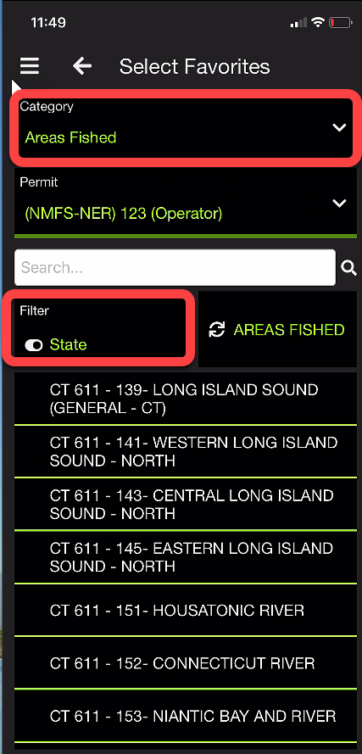
Step 7: Next you will set up Areas Fished and Ports.

Areas Fished has a toggle “Filter” for either State or Federal

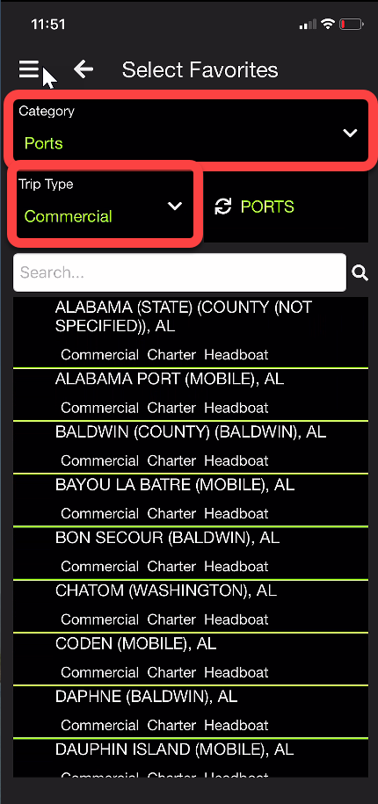

Ports has a drop-down list that allows you to search by “Trip Type”.

Step 8: Next, you will set up your Gear and Dispositions Favorites. You will notice a “Filter by” toggle button below the search box. This button will allow you to switch between or Gears or Dispositions.
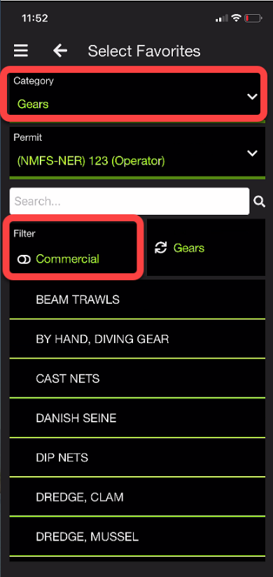
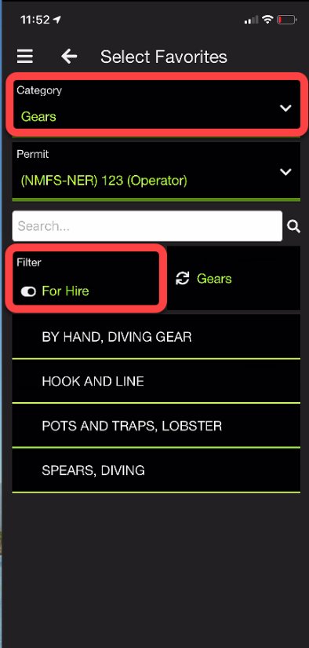

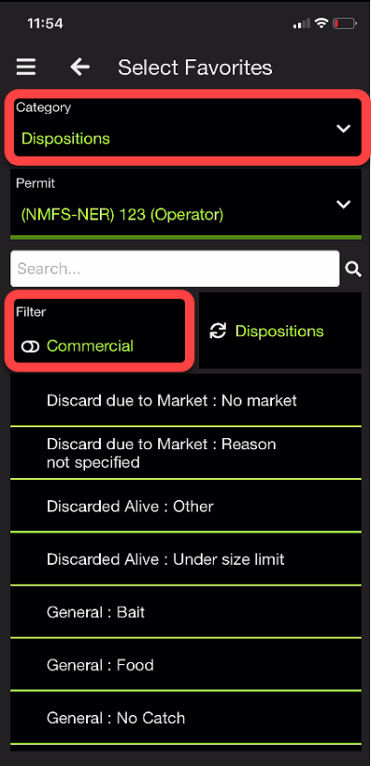
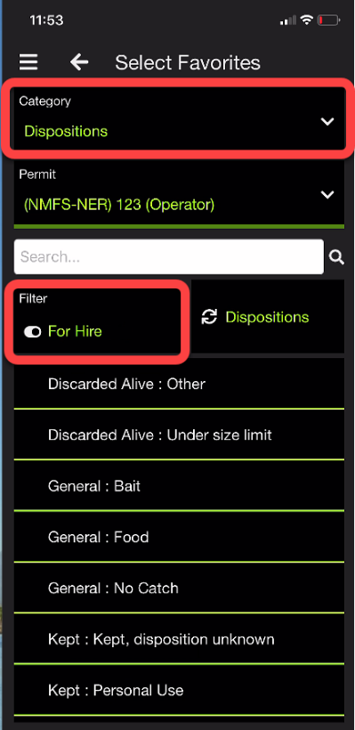

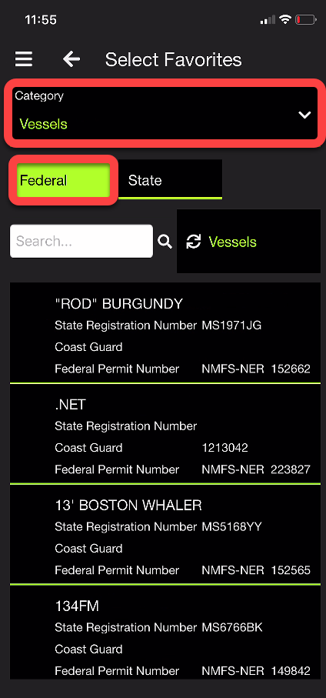
Step 9: Adding in your Vessels. If you have a Federal Vessel you'd like to add, you can search for your vessel within the eTrips database.
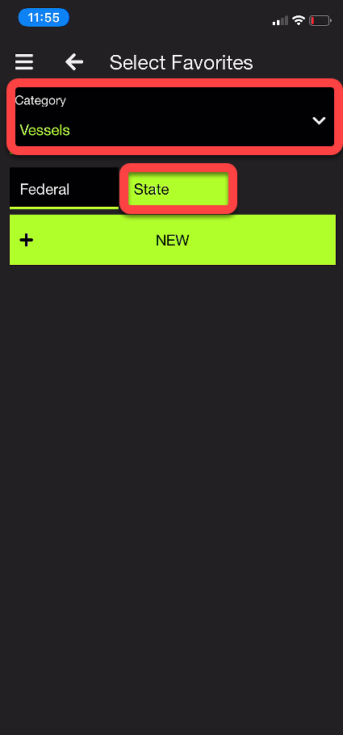

If you have a State Vessel, you'd like to add in you can manually enter your state Vessel information.

Step 10: You can search for Dealers – by name or permit number

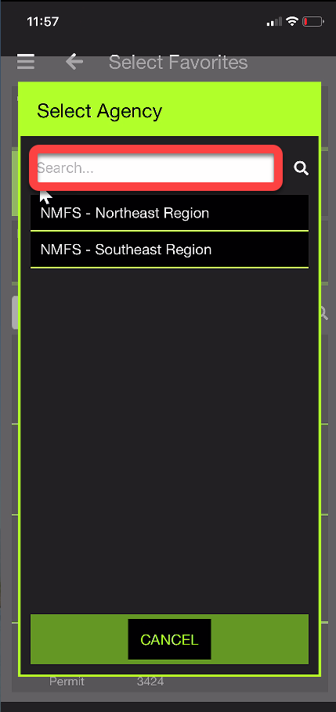
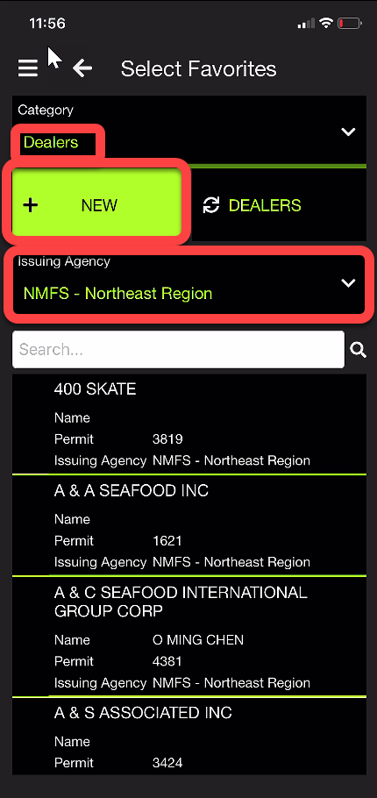

Note: When Adding in a dealer, you will need to get their Dealer Permit number along with the issuing agency of the dealer permit. A STATE permitted dealer will have been issued their permit from the state. A FEDERAL dealer will have their permit issued by a federal agency.

Example: a federally permitted dealer in Georgia would have their permit issued through the NMFS Southeast.

IF YOU DON’T KNOW YOUR DEALERS PERMIT NUMBER OR ISSUING AGENCY, PLEASE CALL US AT 800-984-0810.

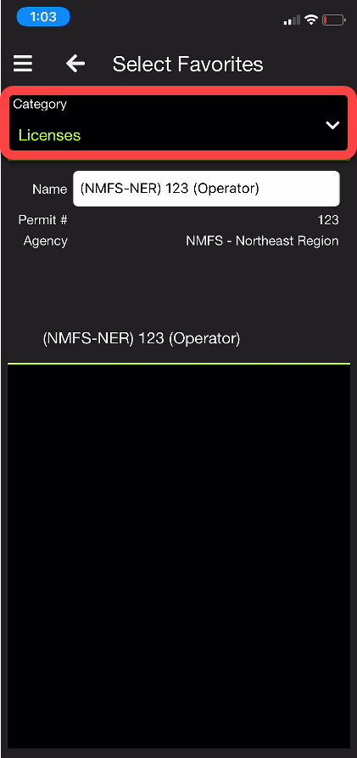
Step 11: The last Favorite you want to set is your License, so that the license(s) you use are available.

Your licenses will download from the ACCSP when you first login. You want to set favorites on each license you will use. Use your NMFS license when fishing on a Federal Vessel, this will ensure the trip is uploaded to the proper federal agency.

Step 12: Now you are ready to begin entering in a trip.
Notice there are two options:

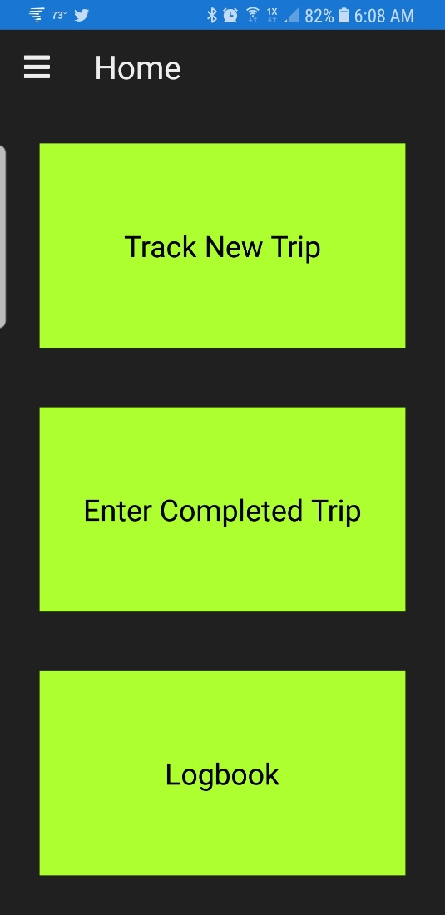

Click Enter Completed Trip and this is the screen you will see:

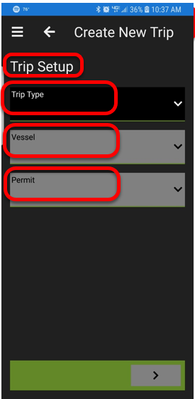
Step 13: Enter the Trip Setup

Selecting the Trip Type button will allow you to toggle between For Hire and Commercial trips.

Select your Vessel

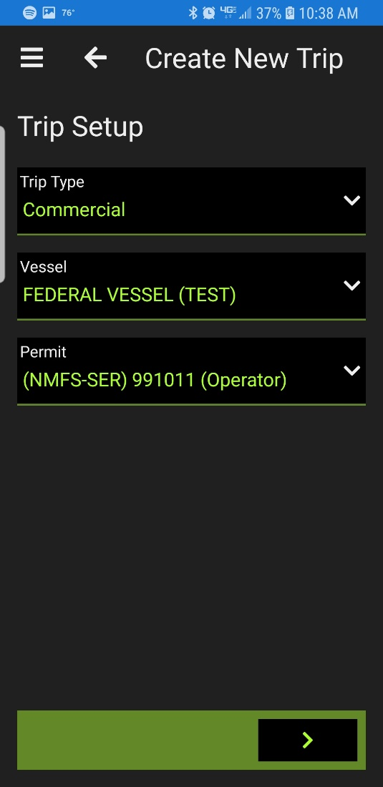
Select the Permit which you will be reporting under

Once you have entered all Trip Setup information you can now enter Trip Details

Step 14: Enter Trip Details

You can give your trip a name to help you identify it

The application will automatically populate your VTR #

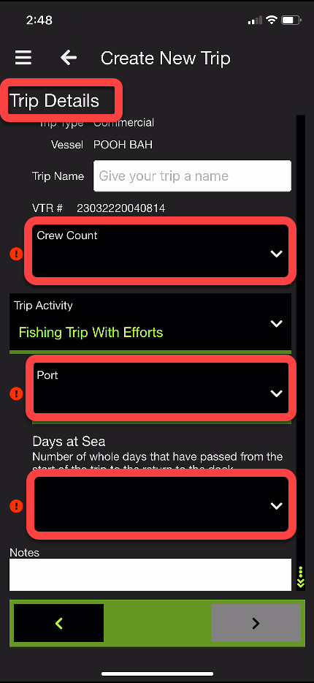
You must enter the Crew Count and Port. – As shown by the symbol:

Indicates a required field

There is also a section where you can enter Notes about your trip. Example: weather conditions or information about customers. These notes are for your eyes only and do not get sent in with your trip data.

NOTE: Depending upon which fishing permit you use, you may have additional, optional or required fields that you can fill out. For Instance: If you are fishing under a South Atlantic permit you can scroll down the page. Captains may need to enter in data such as Fuel Price, Fuel Used, and Charter Fee. These data fields, when filled in, will be sent to the ACCSP data warehouse.

Now that Trip Setup and Trip Details are filled in the Effort Details area is available to fill in
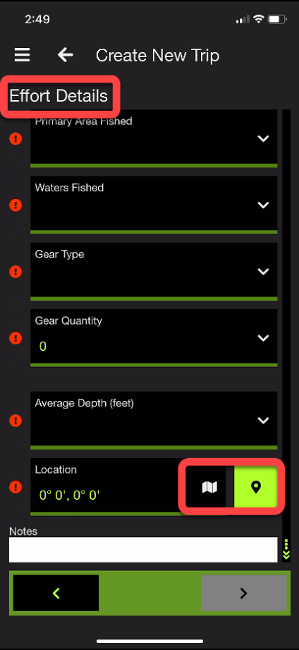
Step 15: The next step is entering your Effort Details. You will be able to select from your preselected favorite to fill out questions such as Waters Fished and Gear Type. The last part of Effort Details is selecting a Location. Select the location button and a map will appear if you have a GPS chip built in or are connected to wi-fi.
You can also select
and enter the location.

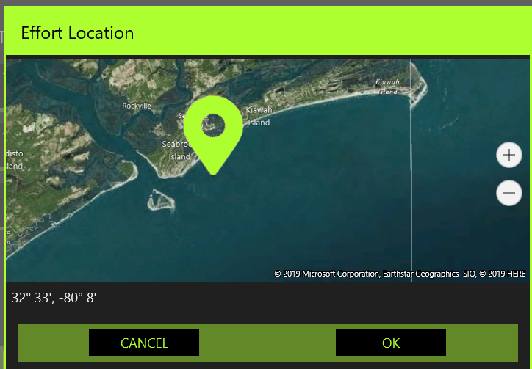

Now that the Effort Details are filled in you are ready to Start Your Trip

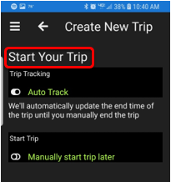
Step 16: The app offers you two options Auto Track This Trip or Do Not Track This Trip.

Auto Track your trip:
When using Auto Track the app will Automatically fill in the Date and Time of your Trip and Effort. You have the option to Start your Trip and/or Effort now or at a later point. It will also GPS stamp your catches as you enter them into the app.

NOTE: This GPS information of your catch stays with the device and does not get sent to the ACCSP/GARFO.

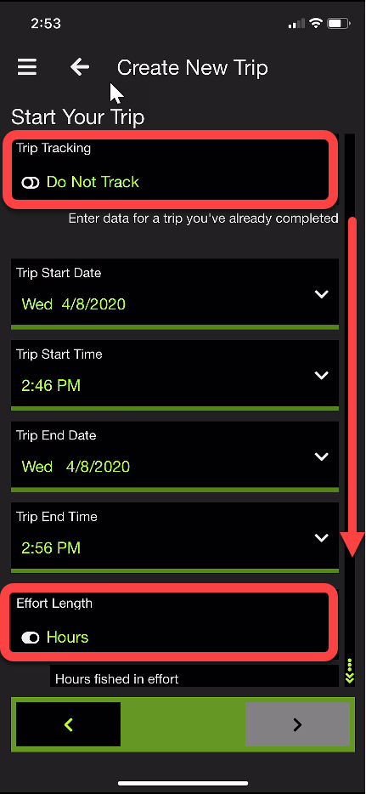
We are going to walk through Do Not Track This Trip, so make sure that option is highlighted.

Enter the Trip Start Date and Time
Enter the Trip End Date and Time

Enter the Hours fished in the first Effort, you may select hours or days. Then scroll down to select the actual time fished
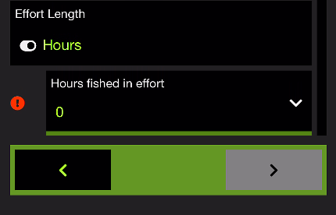

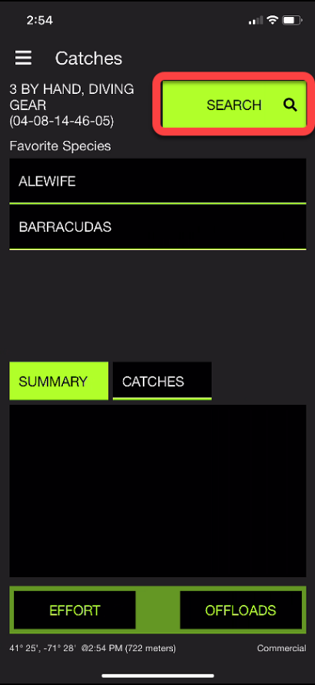
Step 17: Now you can begin entering and editing a Catch. Notice that all the species you selected as Favorites appear in Species. If you want to enter a species all you need to do is select the desired species. If you want to enter a Species that is not in list of Favorites you can search through the data base using the Search feature.

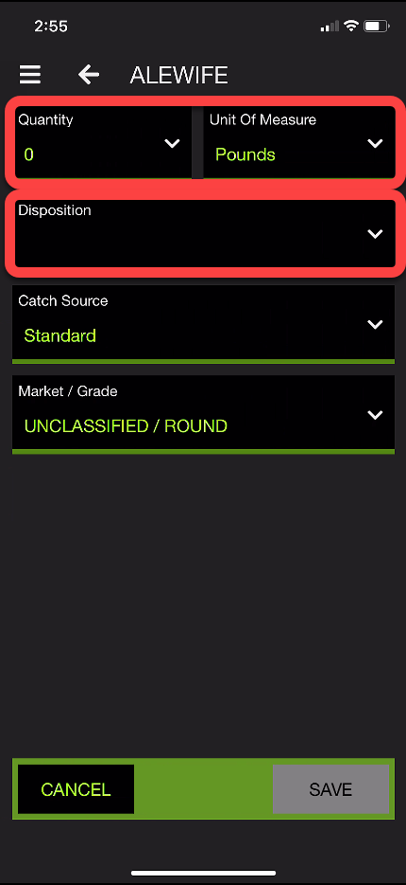
Step 18: After selecting a species you can now enter the details about your catch.

The Unit of Measure can be adjusted depending on trip type to suit your needs.

Length is an optional field you can set with either an average or the actual length of a catch.

When you click on Dispositions you will see the Dispositions you set up in Favorites

Step 19: Once you select your disposition, an offload option should appear. To offload your catch, select the green plus sign highlighted in the picture to the right.

Will bring you to the Create New Offloads page

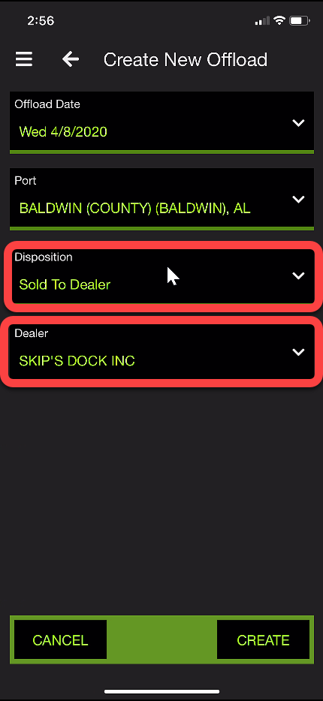
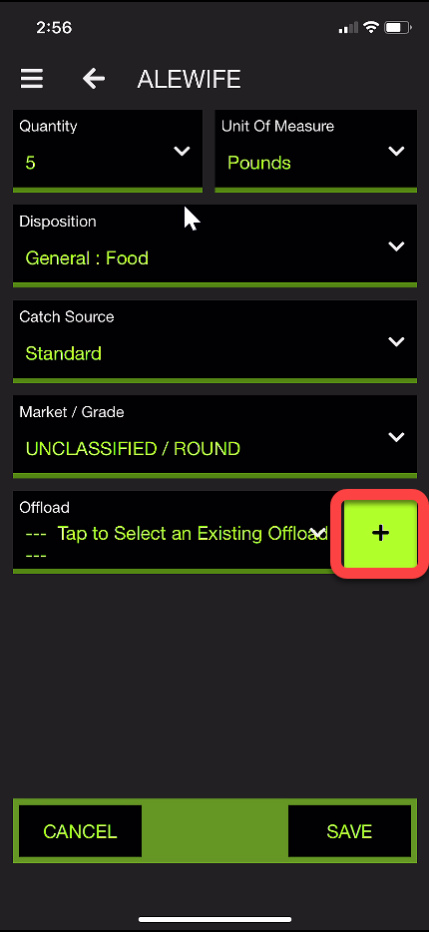

NOTE: Depending upon which fishing permit you use, you may have additional, optional or required fields that you can fill out.

On the lower part of the Catches screen you can see a Summary of your catches

Be sure to record total catch in the app, adding as many species as caught.

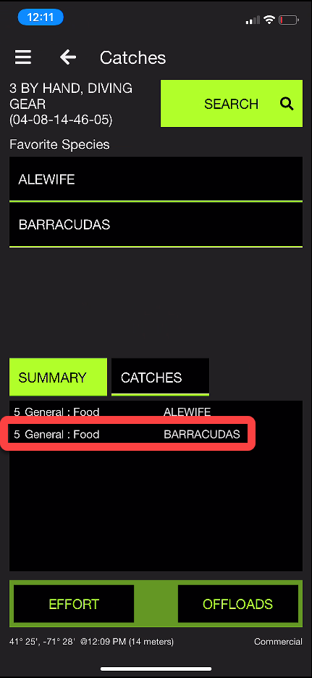
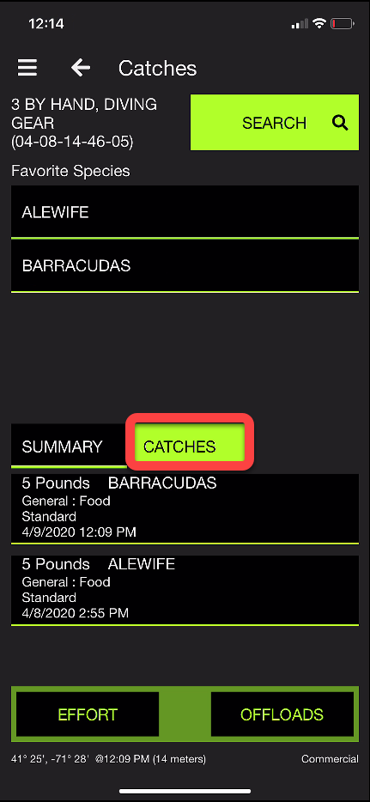
Step 20: By selecting the “catches” tab, you may view and edit your reported catch.

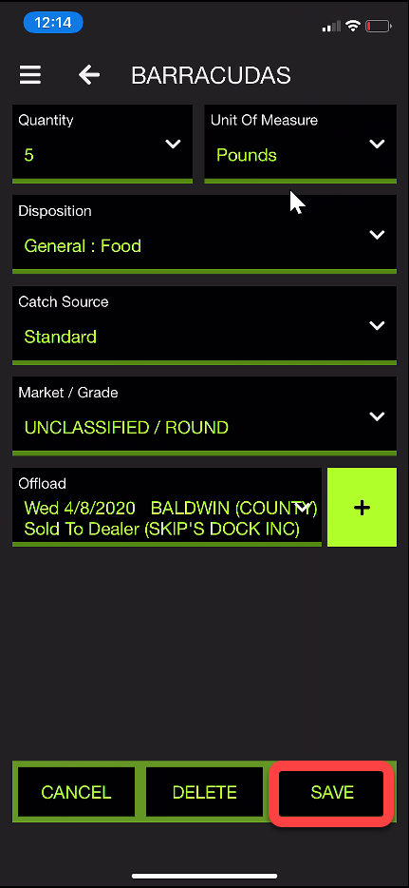
When you click a species to edit it should navigate you to the catch information page for that species. After you edit the species, be sure to select save at the bottom of your screen.

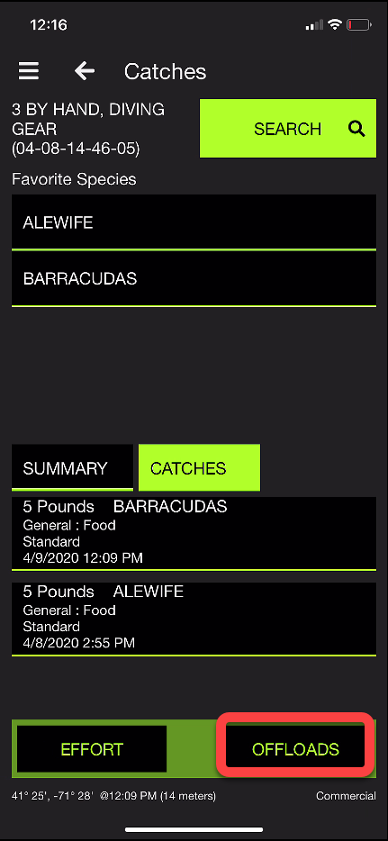
Step 21: When all species catch data is entered into the trip log, navigate to the offloads section of the app by selecting the “offloads” button.

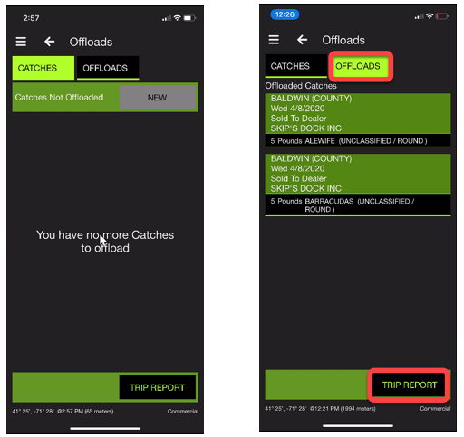
That should bring you to this page where you can view any catch that hasn’t been offloaded, along with an offload section for the catch that has already been offloaded.

Step 22: Now you can submit your trip. In the bottom right corner click the Trip Report button.

Select any unreported trip(s).

Read and check the certifying statement in the lower part of your screen and then click the Submit button.
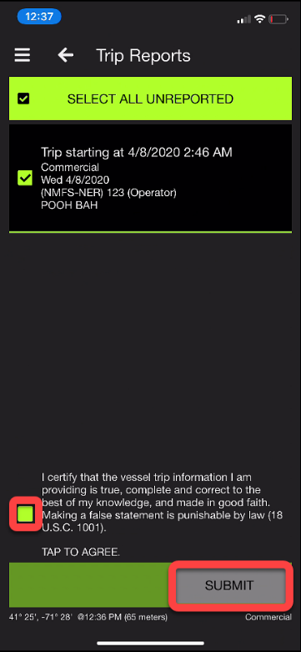

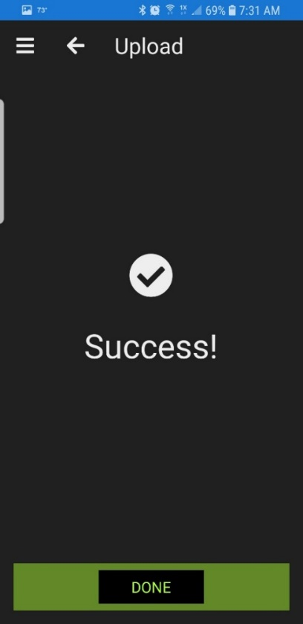

If your trip has successfully uploaded, it should look like this.

If you click the Menu button in the upper left corner and select Logbook you will see all your trips.

All successfully submitted trips will show a cloud with an up arrow to indicate success!

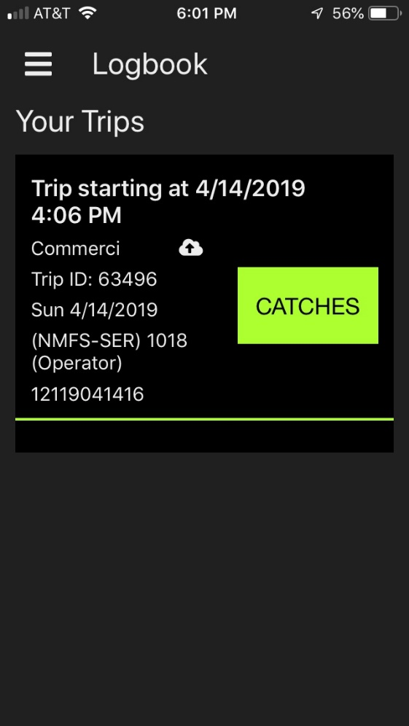

If you receive errors that you do not understand, please call the helpdesk at: 800-984-0810 24 x 7, 365 days a year.

